Analysis of satellite imagery – for groups of two

1. Orient yourself.

The South China Sea it is part of the Pacific Ocean, bounded by southern China, eastern Vietnam and Malay peninsula, western Philippines, northern Borneo, Bangka Belitung Islands and Natuna Islands.

The x-axis coordinates on the map are longitudes, or position in east-west slices of planet.

The y-axis coordinates on the map are latitudes, or position in north-south slices of planet.

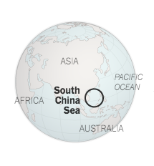

(*NYTimes*)

1. Open the script for today’s satellite data activity.
   1. Open terminal/command line by typing *terminal* into the search feature
   2. Where you can see a blinking cursor in the terminal window, type *ipython notebook*. Then press enter. A browser window should open.

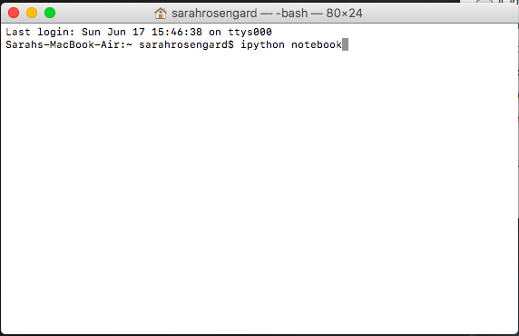

* 1. Once the window opens, navigate into the folder called *algae_module_day1* and open the file called *Module_Satellite_Script.ipynb*
  2. Everything else you do in this activity will work out of this script and folder.

1. Make up to 5-7 maps of chlorophyll concentration (i.e., phytoplankton abundance) over the South China Sea.
   1. Under the heading *#Specify month and year* you will see two lines: *month= 4;* and *year= 2018;*. Where you see *month= 4;* replace the 4 with a month number (1-12) of choice. Where you see *year= 2018;* replace 2018 with a year number (2002-2018) of choice. Note that you can only plot monthly maps from July 2002 to May 2018. Data before and after are unavailable.
   2. At the bottom of the script, you will see a line *savefig('map_name.png')*. Inside the quotation marks (‘)replace *map_name* with a unique title.
   3. Press the arrow button (left of the square/stop button at the top of the page).
   4. After ~30 seconds, you will notice that the map you generated will appear on the browser and also will be saved in the folder you are working out of.
   5. Repeat for every new map. Make at least five maps: at least two years, at least two months in one year, and the same month in at least two different years.

**EXAMPLES**

January 2018 April 2018

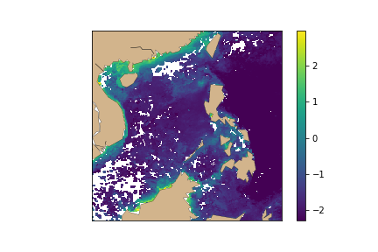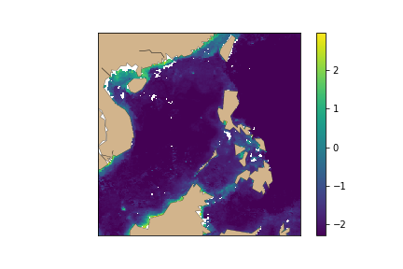

1. General questions to reflect on in your notebook.

What similarities and differences do you observe…

among all maps plotted?

among different months of the same year?

among same months of different years?

How is the information you gather from microscopes different from information you gather from satellite data?

|  |  |  |  |
| --- | --- | --- | --- |
| Map# | Month, year | Why did you choose this date? | Map description |
| Map 1 | mm=___  yyyy=_____ |  |  |
| Map 2 | mm=___  yyyy=_____ |  |  |
| Map 3 | mm=___  yyyy=_____ |  |  |
| Map 4 | mm=___  yyyy=_____ |  |  |
| Map 5 | mm=___  yyyy=_____ |  |  |
| Map 6 | mm=___  yyyy=_____ |  |  |
| Map 7 | mm=___  yyyy=_____ |  |  |